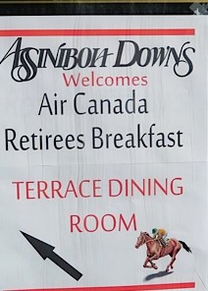

Our next breakfast is January 26, 2019

Place: Assiniboia Downs Racetrack 2nd floor Terrace Dining Room
Time: 09:00
Price: $11.00 plus tip
50/50 draw
Breakfast draw
AC news and updates

Who we are:
We are a chapter of the Manitoba –Saskatchewan District Pionairs.
The Winnipeg Maintenance Retirees Breakfast Club’s mission is to maintain close friendships that were formed while working at the maintenance facility here in Winnipeg. The past is relived through stories, experiences and events in order to preserve and remember a proud history of aviation maintenance here in Winnipeg.
The breakfast club meets throughout the winter months at the Assiniboia Downs Racetrack restaurant on Saturday mornings.

